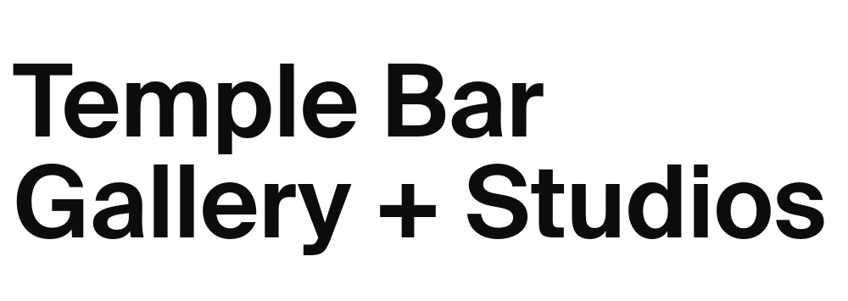
Open Call for Applications
Temple Bar Gallery + Studios and Bétonsalon Dublin/ Paris Residency Exchange 2026

In partnership with the Embassy of France in Ireland, Dublin City Council Arts Office and the Embassy of Ireland, France.
Application Form

Name
Address
Nationality
Telephone
Email

About the Residency
This opportunity will afford an artist the chance to take time to live in Paris
from 01 October–30 November 2026 . It offers accommodation, a stipend of €5,000, and institutional support from Bétonsalon. The accommodation in Couvent des Récollets offers 40–60sqm furnished living space with an equipped kitchen area, sleeping area, bathroom, and desk space. Couvent des Récollets houses artists and researchers from multiple disciplines and is located in the 10th arrondissement of Paris.
The residency offers an artist time to develop their artistic research, engage with an international art scene, build professional networks, and engage with a community of French and international resident artists. The artist will have the chance to visit museums, galleries and other cultural organisations in a major European city. At the beginning of residency, artists will be invited to present their practice to the Bétonsalon curatorial team and from thereafter will be free to explore Paris and undertake their artistic research, with guided support from Bétonsalon.

Founded in 2003, Bétonsalon, is a centre for art and research located within the Université Paris Cité. It is one of the earliest organisations in France to recognise the position of art at the crossroads of various research fields, linking artistic practices to their cultural contexts, and asserting feminist and de-colonial positions. Today, the programme revolves around sensitive/sensory experience as a factor of experimentation around social, racial, gender, and environmental issues. Developing its activities in collaboration with local, national and international organisations, Bétonsalon is a source of situated practices and knowledge, generating new approaches to artistic research across exhibitions and education. It is an accessible and hospitable public institution, where the quality of attention is a daily commitment.

Selection Criteria
To establish your eligibility for this opportunity, we will be assessing your application on the following criteria. Please ensure that you have addressed each of these criteria in this application.

- Professional practicing visual artist
- The artist must be living and/or working within the Dublin City Council administrative area
- Quality of work - relevant to contemporary visual art
- Recent work and activity
- Quality of proposal

Q1. Please complete your artist statement (150 words max)
Please type your answer below. The text box will expand.

Q2. What is your motivation for applying to the Dublin/Paris International Residency Exchange with Bétonsalon? (300 words max)
Please type your answer below. The text box will expand.

Q3. How do you plan to use the opportunity to be in the specific location of Paris? You may mention any institutions, archives, curators, or researchers you would like to engage with.
Please type your answer below. The text box will expand.

Q4. Please tell us how your practice would benefit from this opportunity?
Please type your answer below. The text box will expand.

Enclosures Checklist
Please read fully and carefully the following specifications for supporting documentation.
Required Material + Information:
Completed application form in ‘.doc’ or ‘.pdf’ format.
Up-to-date CV in ‘.doc’ or ‘.pdf’ format.
Work samples
Please submit your work samples in a single PDF no larger than 10mb.
- Maximum of 10 images or videos/video excerpts, with captions (title, date, medium, and dimensions/duration) for each work.
- If required, you may give a brief description of each work.
- If a video is longer than 5 minutes please provide links to a short excerpt (max 3 minutes), in addition to the full-length video.
- We recommend using video hosting sites such as www.youtube.com or www.vimeo.com. Please provide any applicable access passwords within pdf document

Accessibility
Please note, alternative methods of application are accepted for those with access needs. Please get in touch with TBG+S Progamme Curator Michael Hill michael@templebargallery.com for further information.

We do not require work schedules, copies of reviews/press, scans or copies of catalogues, or letters of support/recommendation.

Please note the following before returning your application form and supporting material.

Deadline: Friday 10 April 2026 at 5pm
Email application to: apply@templebargallery.com
Please include the words ‘HIAP Residency 2027’ in the subject line.

If you are unsure about any details regarding your application, please email michael@templebargallery.com.
EDI Policy
Temple Bar Gallery + Studios is committed to its EDI policy to promote equality of opportunity for all visual artists applying, regardless of their gender, sexual orientation, civic or family status, religion, age, disability, socio-economic background, race, or membership of the Travelling community. Therefore, we welcome applications from practicing Visual Artists that are representative of the diversity of Irish society, including, but not limited to any of the characteristics outlined.

Personal Information
All information submitted to Temple Bar Gallery + Studios will be held in the strictest confidence in line with GDPR guidelines and data will only be used in the context of evaluating applications. By submitting your application, you are authorising Temple Bar Gallery + Studios to contact you directly in relation to the open call.

Mark the box with an ‘X’ to receive emails about upcoming Studio and Residency opportunities, exhibitions and events at TBG+S.

Signed: |  | Date:

The Temple Bar Gallery + Studios and Bétonsalon Dublin/Paris Residency Exchange 2026 is made in partnership with the Embassy of France in Ireland, Dublin City Council Arts Office and the Embassy of Ireland, France.
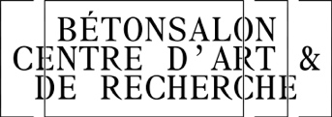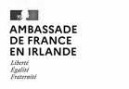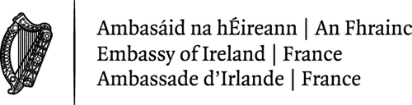

Temple Bar Gallery + Studios is supported by:
