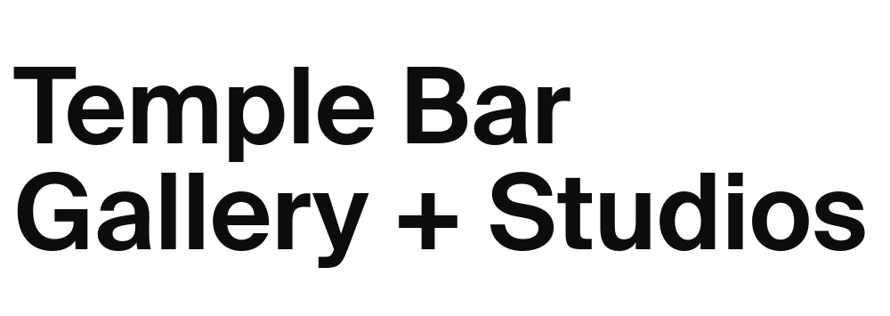
Open Call for Applications
Temple Bar Gallery + Studios Recent Graduate Residency Application Form 2026
Please ensure you have carefully read the Studio Application Guidelines prior to completing the application form. Download the Guidelines.

Please read the FAQs before making your application. An online information Q+A for additional queries will be held Monday 30 March 2025 at 2pm by TBG+S Programme Curator Michael Hill. The session is free to attend and will take place on Zoom. Register for the Online Q+A Session.

Name
Town/City

Nationality
First Language (if not English)
Telephone
Email
College attended
Course taken
Year graduated*
Yes, I would like to receive regular emails about Temple Bar Gallery + Studios exhibition, studio and events programme and opportunities.

We regularly send updates on news and opportunities. Please tick the box below if you wish to stay informed.

*Please note: Temple Bar Gallery + Studios Recent Graduate Residency 2026 is open only to artists who have graduated from a Fine Art (or related) BA/BFA in any recognised university or third level institution in Ireland in the past three years, and Irish artists who have graduated from a Fine Art (or related) BA/BFA outside of Ireland in the past three years (2025/2024/2023).
Accessibility note: Alternative methods of application are accepted for those with access needs. Please get in touch with TBG+S Progamme Curator Michael Hill michael@templebargallery.com for further information.

Selection Criteria:
To establish your eligibility for this opportunity, we will be assessing your application on the following criteria. Please ensure that you have addressed each of these criteria
- Aspiring to be a professional practicing visual artist.
- Quality of work – distinctive, demonstrates fresh ideas, novel artistic approaches, and relevance to contemporary visual culture.
- Recent work and activity – potential for development of ideas and practice.
- Quality of proposal – clarity of communication and documentation.
- Expressed and perceived need – how you will make use of the opportunity.
- Willingness to engage with Temple Bar Gallery + Studios community.

Q1: Please describe your art practice and artistic concerns (max. 200 words).
Please type your answer below. The text box will expand.

Q2: Please indicate your proposed use of the studio over the year long period of the award.
For example: Are you working towards an exhibition? Do you have an idea for a specific project? This could include developing ideas for artworks, collaborations, research, commissions, and development of your work, as well as realised or finalised projects and exhibitions. Be specific. (max. 300 words).
Please type your answer below. The text box will expand.
Please include images of what you describe in Question 2 in your 10 image PDF supporting documentation
Q3: Please tell us how your practice would benefit from being awarded the graduate studio at Temple Bar Gallery + Studios.
For example, it might be helpful to consider how you will use the awarded fee: Materials, equipment, travel, time; or how you would make use of institutional supports through TBG+S: Open studios, curator/artist visits, meeting people. Be specific. (max. 200 words).

Please type your answer below. The text box will expand.

Q4: If you are awarded a studio, are there access or practice-based requirements or preferences we can give consideration to? (Optional)

Please type your answer below. The text box will expand.

A requirement of the award is to host a studio visit with the supporters of the award. We also welcome the awarded artist to participate in paid and supported talks, presentations, open studios about their work as part of the TBG+S Learning + Public Engagement Programme.

Enclosures Checklist:
Please read fully and carefully the following specifications for supporting documentation.
Material + Information: Required fields/material marked *.

Completed application form in ‘.doc’ or ‘.pdf’ format. *
Up-to-date artist CV in ‘.doc’ or ‘.pdf’ format. *
Images: 10 max., laid out in a single ‘.pdf’ document.
- Maximum of 10 images or videos/video excerpts, with captions (title, date, medium, and dimensions/duration) for each work.
- If required, you may give a brief description of each work.
- If a video is longer than 5 minutes please provide links to a short excerpt (max 3 minutes), in addition to the full-length video.
- We recommend using video hosting sites such as www.youtube.com or www.vimeo.com. Please provide any applicable access passwords within pdf document (See p. 4 of the Studio Guidelines for Application 2025). *
Outline of a current artistic project and how you will carry this out using the studio at TBG+S (Optional). Please provide where relevant in ‘.pdf’ or ‘.doc’ format. (1 A4 Page max)

If you wish to send hardcopy catalogues and books as support material to your application, they can be posted to the following address below. To have your documentation returned by post, include a stamped addressed envelope with adequate postage or you can arrange to collect your application from Temple Bar Gallery + Studios. Please specify if you would prefer to donate your publications to the Temple Bar Gallery + Studios library. Temple Bar Gallery + Studios cannot take responsibility for any materials lost or damaged so please do not send publications of which you do not have extra copies.

Studio Applications
Temple Bar Gallery + Studios
5-9 Temple Bar
Dublin 2

Please note the following before returning your application form and supporting material.

Recent Graduate Residency Applications
Deadline: Friday 10 April 2026, 5pm.
Email application to: apply@templebargallery.com
Please include the words ‘Recent Graduate Residency 2026’ in the subject line.

EDI Policy
Temple Bar Gallery + Studios is committed to its EDI policy to promote equality of opportunity for all visual artists applying, regardless of their gender, sexual orientation, civic or family status, religion, age, disability, socio-economic background, race, or membership of the Travelling community. Therefore, we welcome applications from practicing Visual Artists that are representative of the diversity of Irish society, including, but not limited to any of the characteristics outlined.

Please note: All information submitted to Temple Bar Gallery + Studios will be held in the strictest confidence in line with GDPR guidelines and data will only be used in the context of evaluating 2026 Studio Applications. By submitting your application, you are authorising Temple Bar Gallery + Studios to contact you directly in relation to the open call.

Signed: |  | Date:

If you are unsure about any element of your application, please email michael@templebargallery.com with any questions and queries.

Temple Bar Gallery + Studios is supported by:
