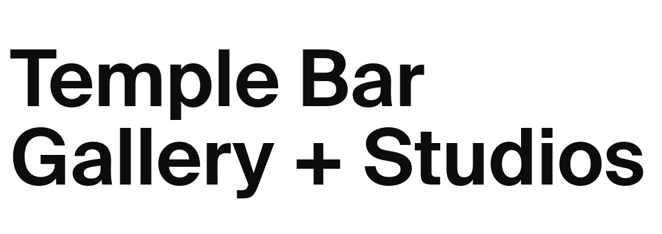
Open Call for Applications
Temple Bar Gallery + Studios / Helsinki International Artist Programme (HIAP) Residency Exchange 2027 Application Form

Name
Address
Nationality
Telephone
Email
Website

Selection Criteria
To establish your eligibility for this opportunity, we will be assessing your application on the following criteria. Please ensure that you have addressed each of these criteria in this application.

- Professional practicing visual artist
- An artist living in the Republic of Ireland or an Irish artist living anywhere in the world
- Quality of work - relevant to contemporary visual art
- Recent work and activity
- Quality of proposal
- Artists previously awarded TBG+S/HIAP Residency Exchange are not eligible to apply. However, applicants whose previous applications were not taken forward are welcome to apply this year with a new application.

Q1. Please complete your artist’s statement (150 words max)

Please type your answer below. The text box will expand.

Q2. How do you plan to use the time and resources offered by HIAP/TBG+S (300 words max)

Please type your answer below. The text box will expand.

Q3. Please tell us how you feel that you would benefit from this residency (150 words max)

Please type your answer below. The text box will expand.

Q4. Please list any other International Residency Programme you have participated in recently
Please type your answer below. The text box will expand.
Enclosures Checklist
Please read fully and carefully the following specifications for supporting documentation.
Required Material + Information:
Completed application form in ‘.doc’ or ‘.pdf’ format.
Up-to-date CV in ‘.doc’ or ‘.pdf’ format.
Work samples
Please submit your work samples in a single PDF no larger than 10mb.
- Maximum of 10 images or videos/video excerpts, with captions (title, date, medium, and dimensions/duration) for each work.
- If required, you may give a brief description of each work.
- If a video is longer than 5 minutes please provide links to a short excerpt (max 3 minutes), in addition to the full-length video.
- We recommend using video hosting sites such as www.youtube.com or www.vimeo.com. Please provide any applicable access passwords within pdf document
Accessibility
Please note, alternative methods of application are accepted for those with access needs. Please get in touch with TBG+S Progamme Curator Michael Hill michael@templebargallery.com for further information.

We do not require work schedules, copies of reviews/press, scans or copies of catalogues, or letters of support/recommendation.

Please note the following before returning your application form and supporting material.

Deadline: Friday 10 April 2026 at 5pm
Email application to: apply@templebargallery.com
Please include the words ‘HIAP Residency 2027’ in the subject line.

If you are unsure about your application, please email michael@templebargallery.com with any questions and queries.
EDI Policy
Temple Bar Gallery + Studios is committed to its EDI policy to promote equality of opportunity for all visual artists applying, regardless of their gender, sexual orientation, civic or family status, religion, age, disability, socio-economic background, race, or membership of the Travelling community. Therefore, we welcome applications from practicing Visual Artists that are representative of the diversity of Irish society, including, but not limited to any of the characteristics outlined.

Personal Information
All information submitted to Temple Bar Gallery + Studios will be held in the strictest confidence in line with GDPR guidelines and data will only be used in the context of evaluating applications. By submitting your application, you are authorising Temple Bar Gallery + Studios to contact you directly in relation to the open call.

Please mark this box with an ‘X’ you would like to receive emails regarding future opportunities for the studio and residency programme, exhibitions, news, and events at Temple Bar Gallery + Studios.

Signed: |  | Date:

The TBG+S/HIAP International Residency Exchange is kindly supported by the Finnish Institute, UK + Ireland


Temple Bar Gallery + Studios is supported by:
